 COMPANY LEGAL NAME

Company:

COMPANY ADDRESS
Address:

MUTUAL NONDISCLOSURE AGREEMENT

This Mutual Nondisclosure Agreement (the “Agreement”) is entered into by and between the company identified above (“Company”) and Digital.ai Software, Inc., a Delaware Corporation, with its principal address at 555 Fayetteville Street, Suite #210, Raleigh, NC 27601, on behalf of itself and Digital.ai Affiliates (collectively, "Digital.ai") and is effective the date executed by Company below (the “Effective Date”).

Digital.ai and Company are pursuing discussions to analyze further business opportunities between them (the "Business Purpose"). The parties recognize that in the course of such discussions, it may become necessary for one or both parties to disclose Confidential Information (as defined below) orally, visually and/or in writing. Both parties intend that any Confidential Information disclosed by either party shall be used by the other party only to further the Business Purpose. Further, both parties intend that any Confidential Information disclosed shall be protected from further disclosure by the terms of this Agreement.

NOW, THEREFORE, in consideration of the discussions and sharing of information between the parties, and the promises, conditions, covenants and warranties herein contained, the parties agree as follows:

1. Definitions.
For purposes of this Agreement, the following terms shall have the following meanings:

(a) "Confidential Information" shall mean all information and data of either party to this Agreement, whether of a technical, business or other nature, including without limitation, trade secrets, know-how and information relating to the technology, customers, vendors, business or strategic plans, promotional and marketing activities, computer programs, finances and other business affairs of such party, in whatever form or medium, that is (i) not generally known to the public, (ii) the subject of reasonable efforts on the part of the Disclosing Party to protect its confidentiality, and (iii) furnished or disclosed by the Disclosing Party or its Affiliates to the Receiving Party.

(b) “Company Affiliate” shall mean a corporate or business entity anywhere in the world, directly or indirectly controlling or controlled by or in common control with a party hereto, where “control” is defined as (i) the ownership of at least 50% of the equity or beneficial interests of such entity; or (ii) the right to vote for or appoint a majority of the board of directors or other governing body of such entity; or (iii) the power to exercise a controlling influence over the management or policies of such entity.

(c) "Digital.ai Affiliate" shall mean any entity that is directly or indirectly, through one or more intermediaries, controlled by Digital.ai Software Holdings, Inc.

(d) "Disclosing Party" shall mean the party disclosing Confidential Information.

(e) "Receiving Party" shall mean the party receiving
disclosure of the Confidential Information.

2. Applicability.
This Agreement shall apply to all Confidential Information disclosed by one party to the other party. For the avoidance of doubt, this Agreement and the non-disclosure obligations contained herein shall apply to both Company Affiliates and Digital.ai Affiliates as well as to Confidential Information of Company Affiliates and Digital.ai Affiliates.

3. Nondisclosure Obligation.
Each party agrees:

(a) to hold the other party's Confidential Information in strict confidence;

(b) to exercise at least the same care in protecting the other party's Confidential Information from disclosure as the party uses with regard to its own similar confidential information, but in any event no less than reasonable care;

(c) not to disclose such Confidential Information to third parties; and

(d) not to use any Confidential Information for any purpose except for the Business Purpose.

4. Disclosure to Employees or Consultants.
Each party may disclose the other party's Confidential Information to its responsible employees and consultants with a bona fide need to know, but only to the extent necessary to carry out the Business Purpose. Each party agrees to instruct all such employees and consultants not to disclose such Confidential Information to third parties, without the prior written permission of the Disclosing Party. The Receiving Party shall be responsible for the actions or omissions of (a) its employees and consultants or (b) any third party to which it discloses Confidential Information of the Disclosing Party.

5. Non-Confidential Information.
Confidential information shall not include information which:

(a) is now or hereafter becomes, through no act or omission on the part of the Receiving Party, generally known or available within the software and e-commerce or internet industry, or is now or later enters the public domain through no act or omission on the part of the Receiving Party;

(b) was acquired by the Receiving Party before receiving such information from the Disclosing Party and without restriction as to use or disclosure;

(c) is hereafter rightfully furnished to the Receiving Party by a third party, without restriction as to use or disclosure;

(d) is information which the Receiving Party can document was independently developed by the Receiving Party without use of or reference to the Confidential Information;

(e) is required to be disclosed by a government agency to further the objectives of this Agreement or by a proper court of competent jurisdiction, provided the Receiving Party uses its best efforts to minimize the disclosure of such information and will consult with and reasonably assist the Disclosing Party in obtaining a protective order prior to such disclosure at the sole cost of the Disclosing Party; or

(f) is disclosed with the prior written consent of the Disclosing Party.

6. Removal of Confidential Materials.
To the extent applicable, each party agrees not to remove any materials or tangible items containing any of the other party's Confidential Information from the premises of the Disclosing Party without the Disclosing Party's consent. Each party agrees to comply with any and all terms and conditions that the Disclosing Party imposes upon approved removal of such materials or items, including without limitation that the removed materials or items must be returned by a certain date, and that no copies of the removed materials or items are to be made.

7. Return of Confidential Information.
Upon the Disclosing Party's request, the Receiving Party will promptly destroy or return to the Disclosing Party all materials or tangible items containing the Disclosing Party's Confidential Information and all copies thereof. Notwithstanding the foregoing, the Receiving Party may retain copies of any computer records or files containing Confidential Information which have been created pursuant to any automatic archiving or back-up procedures which cannot be reasonably deleted, provided that the parties (a) shall not disclose, access or use any such records or files following the date on which the parties would have otherwise destroyed or returned the Confidential Information and (b) hold any such materials in accordance with the terms and conditions of this Agreement for so long as they are retained .

8. Intellectual Property Rights.

(a) No Implied Rights. The parties mutually agree that other than as provided for in section 8(b) herein, each party recognizes and agrees that nothing contained in this Agreement will be construed as granting any rights to the Receiving Party, by license or otherwise, to use any of the Disclosing Party's Confidential Information except as specified in this Agreement for the Business Purpose. Nothing in this Agreement will serve to impair the right of either party hereunder, be it at any given time a Receiving Party or a Disclosing Party hereunder, to independently develop, make, use, procure, or market products or services now or in the future that may be similar to or competitive with those offered by the other party hereto, nor to require either party to disclose any planning or other information to the other.

(b) Trial Use. Customer may access and use any Digital.ai Software, Redistributable Components, and/or Documentation (such capitalized terms having the meanings ascribed to in Digital.ai’s Master Subscription Agreement available at https://digital.ai/legal/master-subscription-agreement/ (or its successor location) as may be updated by Digital.ai from time to time) provided to Customer by Digital.ai on a trial basis, for a 30 day period (the “Trial Period”). At the end of the Trial Period, Customer’s right to access and use such Software, Redistributable Components, and/or Documentation, as provided herein, shall automatically expire and Customer agrees to cease all access and use thereof. For purposes of any trial under this provision, Digital.ai represents and warrants that it has the right, title and interest to provide the Software, Redistributable Components, and/or Documentation and perform its obligations in accordance with the terms hereof. EXCEPT FOR THE FOREGOING, CUSTOMER AGREES THAT THE SOFTWARE, REDISTRIBUTABLE COMPONENTS, AND/OR DOCUMENTATION ARE PROVIDED “AS IS” AND DIGITAL.AI DISCLAIMS ALL OTHER WARRANTIES, EXPRESS OR IMPLIED, HEREUNDER INCLUDING THE IMPLIED WARRANTIES OF MERCHANTABILITY, FITNESS FOR A PARTICULAR PURPOSE AND NON-INFRINGEMENT.

9. Equitable and Legal Relief.
Each party acknowledges that all of the Disclosing Party's Confidential Information is owned solely by the Disclosing Party (and/or its licensors) and that the unauthorized disclosure or use of such Confidential Information may cause irreparable harm and significant injury, the degree of which may be difficult to ascertain. Accordingly, each party agrees that the Disclosing Party shall have the right to seek an immediate injunction from any court of competent jurisdiction enjoining breach of this Agreement and/or disclosure of the Confidential Information. Each party shall also have the right to pursue any other rights or remedies available at law or equity for such a breach.

10. Term.
This Agreement shall remain in full force and effect for a period equal to a) two (2) years from the Effective Date, or b) two (2) years from the last date of a disclosure of Confidential Information made hereunder, whichever is later (the "Term"), at which time this Agreement shall expire. For the avoidance of doubt, those obligations of confidentiality with respect to any Confidential Information that is a trade secret shall survive for so long as such item remains a trade secret as defined under applicable law.

11. Termination.
(a) Either party may terminate this Agreement, with or without cause, prior to the expiration of the Term, by giving notice of termination to the other party. The Agreement shall terminate immediately upon receipt of such notice.

(b) Upon termination of this Agreement, the Receiving Party shall cease to use any Confidential Information and shall comply with Section 7 hereof within twenty (20) days of the date of termination. Upon the request of the Disclosing Party, an officer of the Receiving Party shall certify that the Receiving Party has complied with its obligations in this Section 11 (b).

(c) Notwithstanding the termination of this Agreement, the Receiving Party's obligations in Section 3 hereof shall survive for a period of two (2) years following such termination.

12. Miscellaneous.

12.1 Governing Law.
This Agreement and performance hereunder shall be exclusively governed by and construed under the laws of the Commonwealth of Massachusetts, without reference to principles of conflict of laws.

12.2 Severability.
Each provision of this Agreement is severable; if any provision is declared void, illegal, or unenforceable, such provision shall be modified by the appropriate judicial body to the minimum extent necessary to render it valid, legal, and enforceable while effectuating insofar as possible the basic purposes of such provision. The remaining provisions shall remain in full force and effect.

12.3 Amendment.
No amendment, modification, supplement or other purported alteration of this Agreement shall be binding upon the parties unless it is in writing and is signed on behalf of the parties' authorized representatives. Any such amendment shall be incorporated into this Agreement by this reference.

12.4 Notices.
Any notice required or permitted by this Agreement shall be in writing, in the English language, and shall be sent by prepaid registered or certified mail, return receipt requested, addressed to the other party at the address shown at the beginning of this Agreement or at such other address for which such party gives notice hereunder. Such notice shall be deemed to have been given three (3) days after deposit in the mail or, if via express overnight courier, the next day, except that notice of change of address shall be effective only upon receipt.

12.5 No Assignment.
Neither party may assign its rights under this Agreement without the written consent of the other party, provided however, either party may, without such consent, assign this Agreement and any of its rights or obligations hereunder in connection with the transfer or sale of all or substantially all of its business, or in the event of its merger, reorganization, consolidation, change in control, or similar transaction.

12.6 Waiver.
No delay, omission, or failure to exercise any right or remedy provided for in this Agreement shall be deemed to be a waiver thereof or an acquiescence in the event giving rise to such remedy (but every such right or remedy may be exercised as the party exercising such right or remedy deems expedient).

12.7 Interpretation.
Headings used in this Agreement are for reference purposes only and in no way define, limit, construe or describe the scope or extent of such section or in any way affect this Agreement. This Agreement shall be construed within its fair meaning and no inference shall be drawn against the drafting party in interpreting this Agreement.

12.8 Counterparts.
This Agreement may be executed in one or more counterparts, each of which shall be deemed an original, but all of which together shall constitute one and the same instrument. Faxed or electronic signatures will be considered the equivalent of an original signature and shall be acceptable to bind the parties and shall not affect the validity of this Agreement. Notwithstanding the foregoing, each party agrees to execute an original of this Agreement and to promptly provide the other party with an original signature at the request of that party.

12.9 Entire Agreement.
This Agreement, including any attachments or exhibits to this Agreement, constitutes the entire understanding and agreement of the parties with respect to its subject matter and supersedes all prior and contemporaneous agreements or understandings between the parties. This Agreement has been written in the English language and, in the event of any conflict or inconsistency between the English-language version and any translation hereof, the English language version shall prevail.

IN WITNESS WHEREOF, intending to be legally bound, the parties hereto have executed this Agreement by a duly authorized representative and acknowledge that they understand and agree to be bound by the terms and conditions of this Agreement.

Signed for and on behalf of Digital.ai | Signed for and on behalf of Company
Signature:  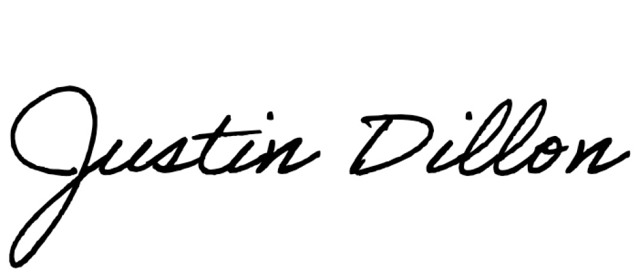 | Signature:
By (name): Justin Dillon | By (name):
Title: Associate General Counsel | Title:
 | Effective Date:

